ECE/CS 252 Week 1 & 2 Review
Wk1: Universal Computing Devices
- Turing Machine: proposed by Alan Turing in late 1930s
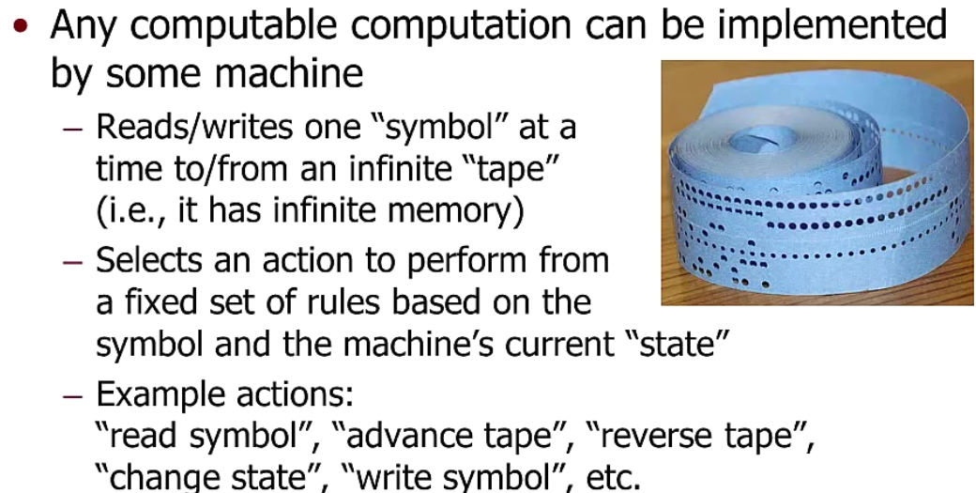
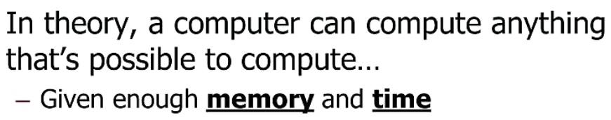

- Some History:
- 1947 first transistor
- 1958 UW Alumni Jack Kilby first IC
- 1971 Intel first Microprocessor
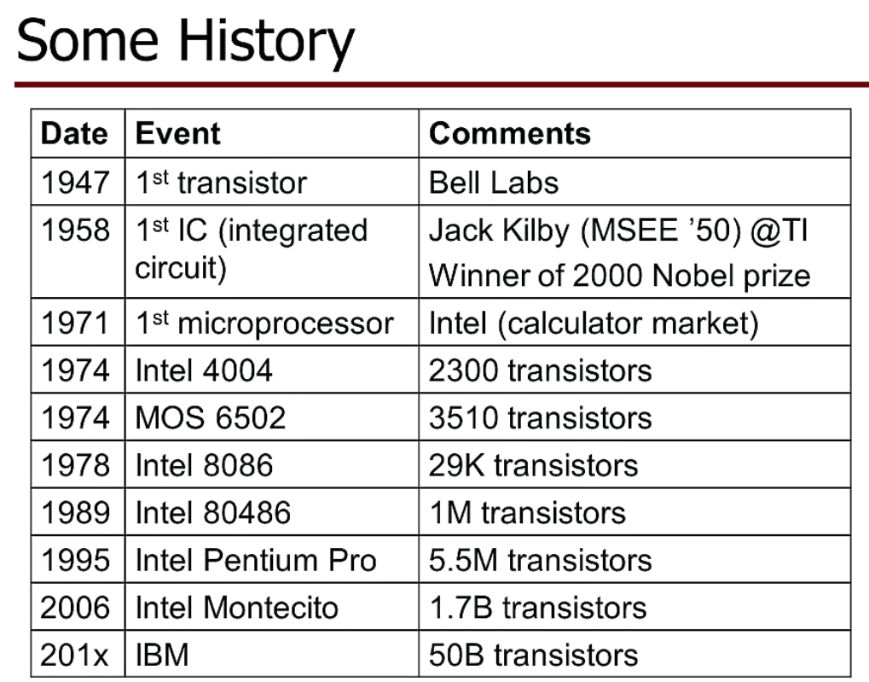

- Moor’s Law (Intel cofounder):
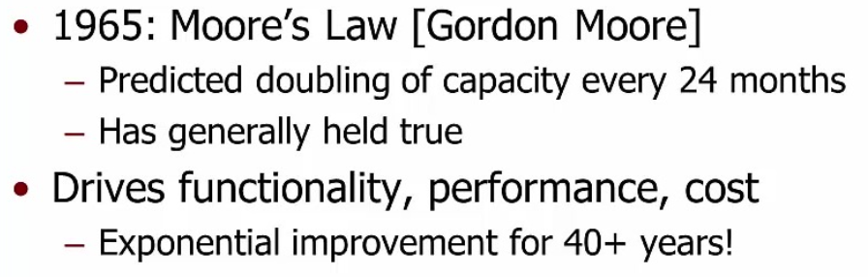


- Processor, CPU (central processing unit)
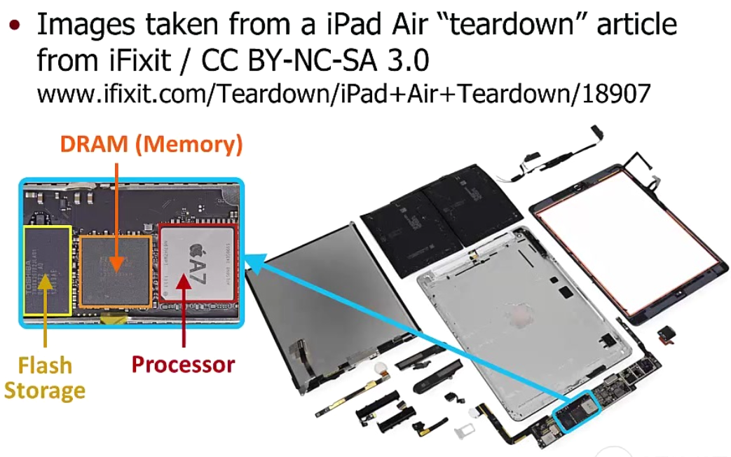
- Abstraction Layer
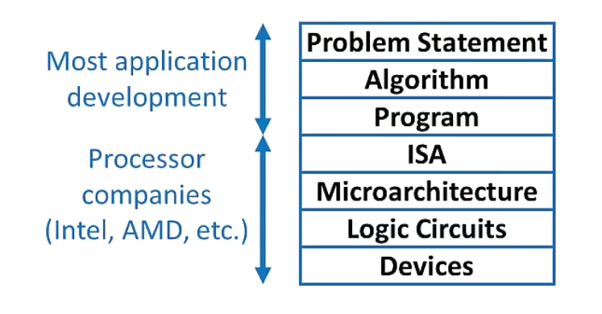
ISA -> think of “assembly language”, the lowest level before HARDWARE
-> a protocol, language, or covention
Microarchitecture -> the highest level of HARDWARE
-> think of general architecture, e.g. Intel / Apple are doing it differently hardware-wise, but both support ISA language, so people writing software does not need to worry about hardware differences
-> using “Logic Circuits” , “transistors”, think of Lego building blocks

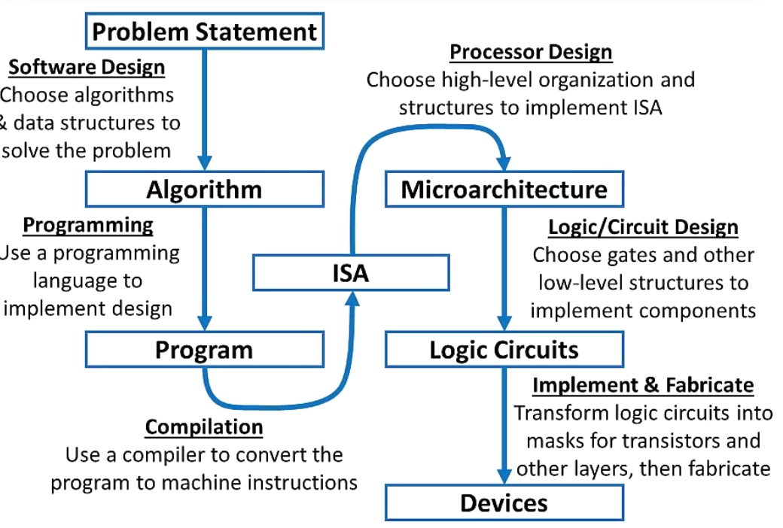
- Analog vs Digital
Think of light switch as example. Real word is analog, but we treat it as digital (ON/OFF, 1/0) for easy processing in computer.
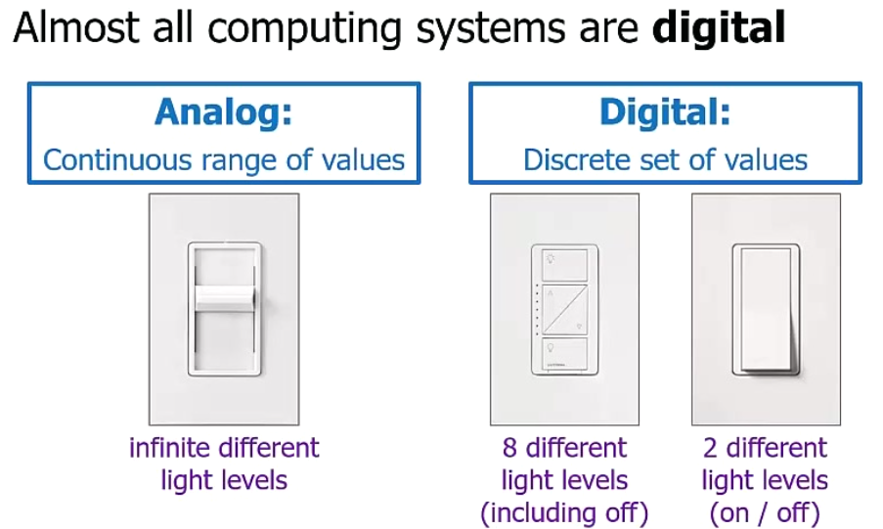
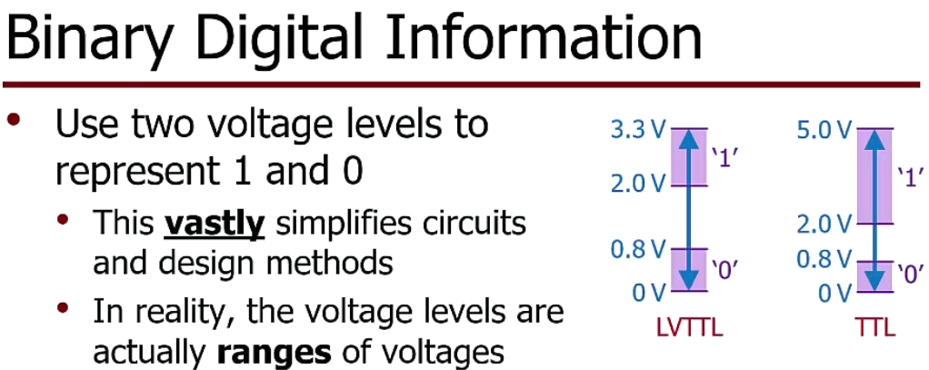

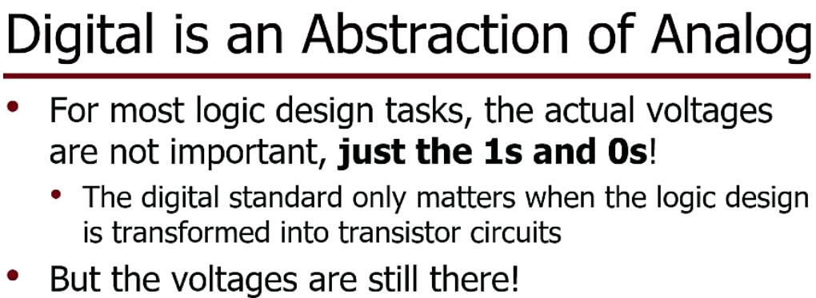

- In computer, everything is just sequences of 1s and 0s
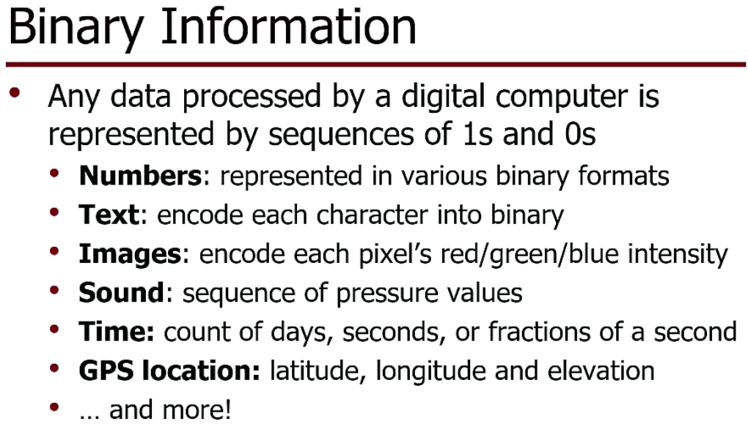

Wk2: Number Representation, Convention, Calculations
Decimal: base 10 base also called the radix
Binary: base 2, Octal: base 8, Hex: base 16
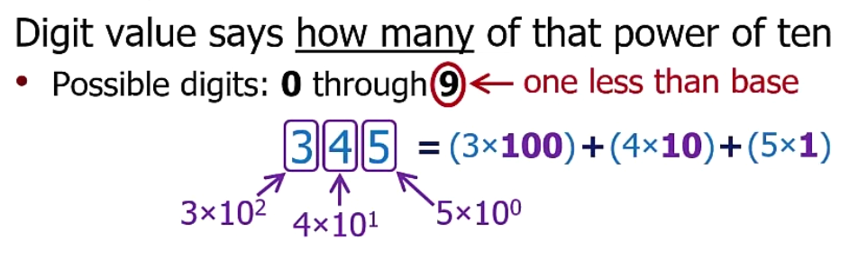

Binary: base 2
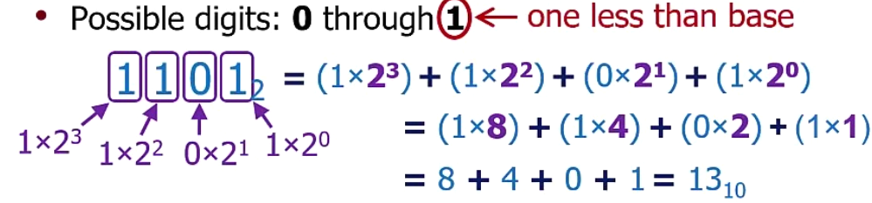
Octal: base 8
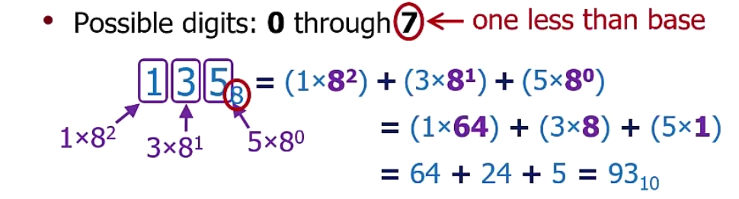
Hex: base 16
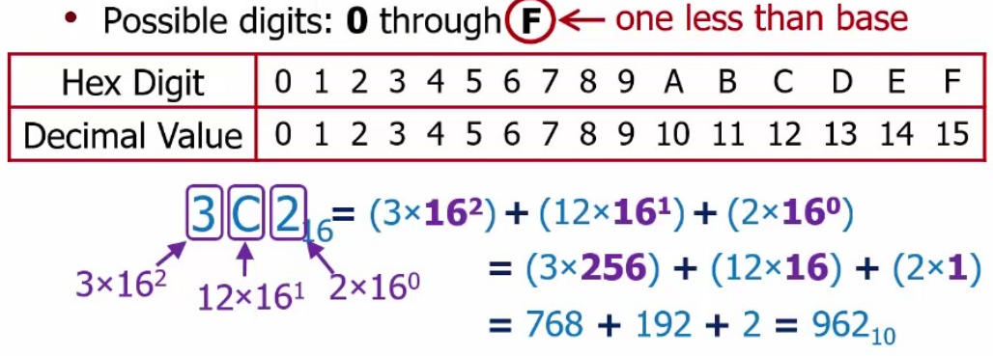
Ranges, how many numbers: think of Decimal case, then apply the same logic
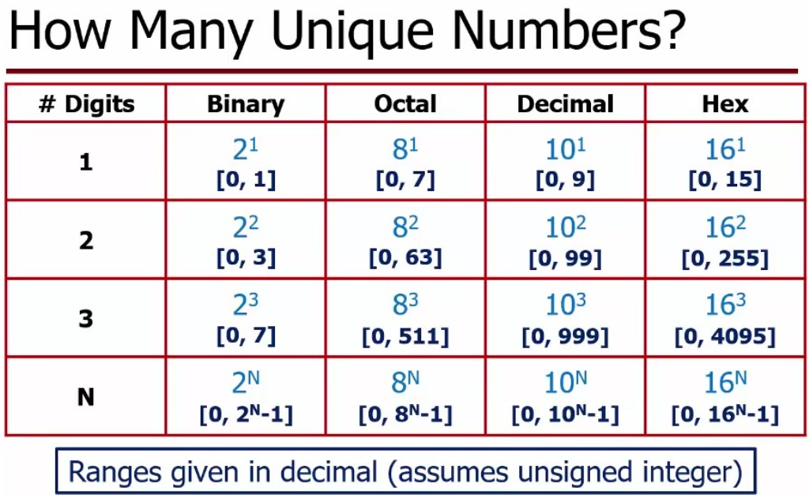
Summary
- Human is good at Decimal, Computer good at Binary, We use Octal / Hex as helpful to both.
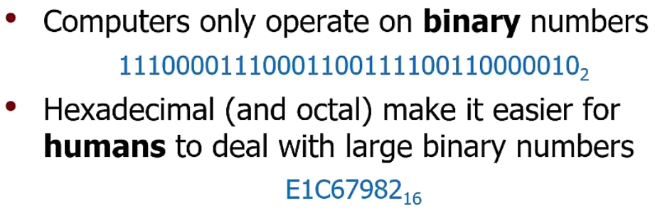
- It is easy to convert Binary <-> Oct/Hex, therefore easy to convert Oct <-> Hex.
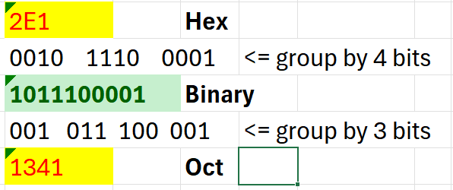
Value vs Number
- A Value is a particular quantity
- A Number is a way to represent a value, think of as string of digits. Format matters.
Same string “110” -> different value, if it is in decimal, binary, oct, hex format.
Same value 50 (Decimal) -> different number string, “50” decimal, “110010” binary, “62” octal, “32” hex
Base Conversion: universal method
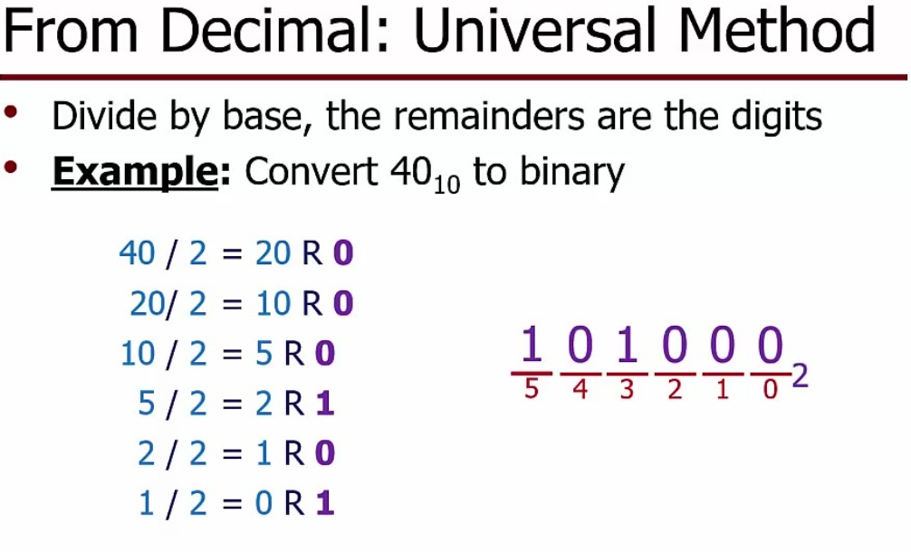
Binary <-> Hex MUST memorize, write the table as 1st thing
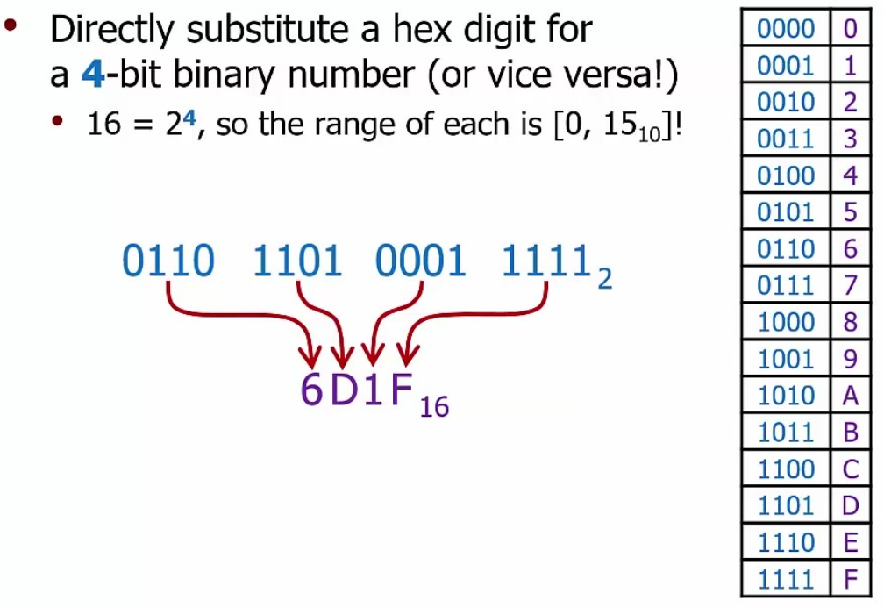
Binary to Octal MUST memorize,1st half of Hex table
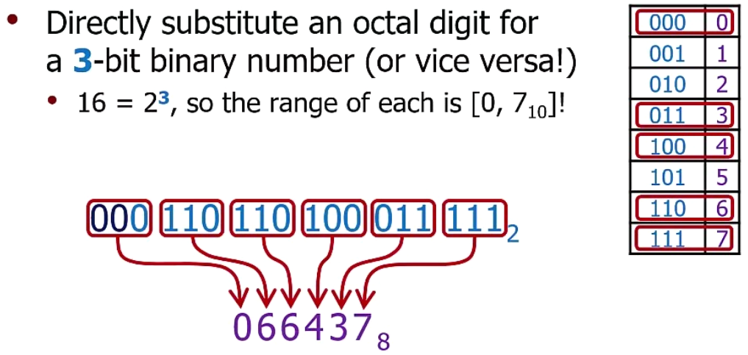
Octal <-> Hex is easy too
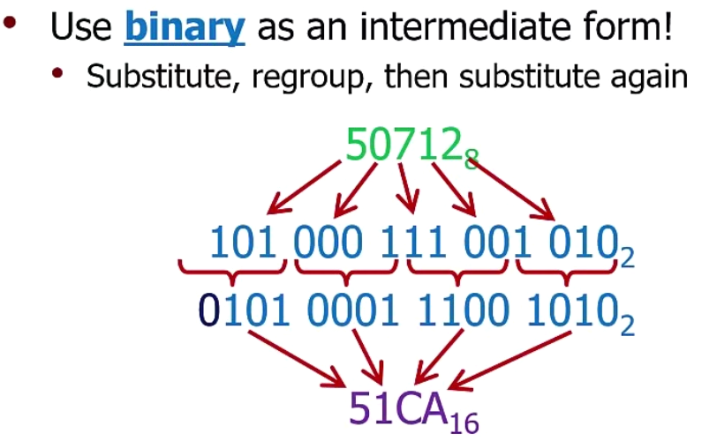

Memorize the following two tables!
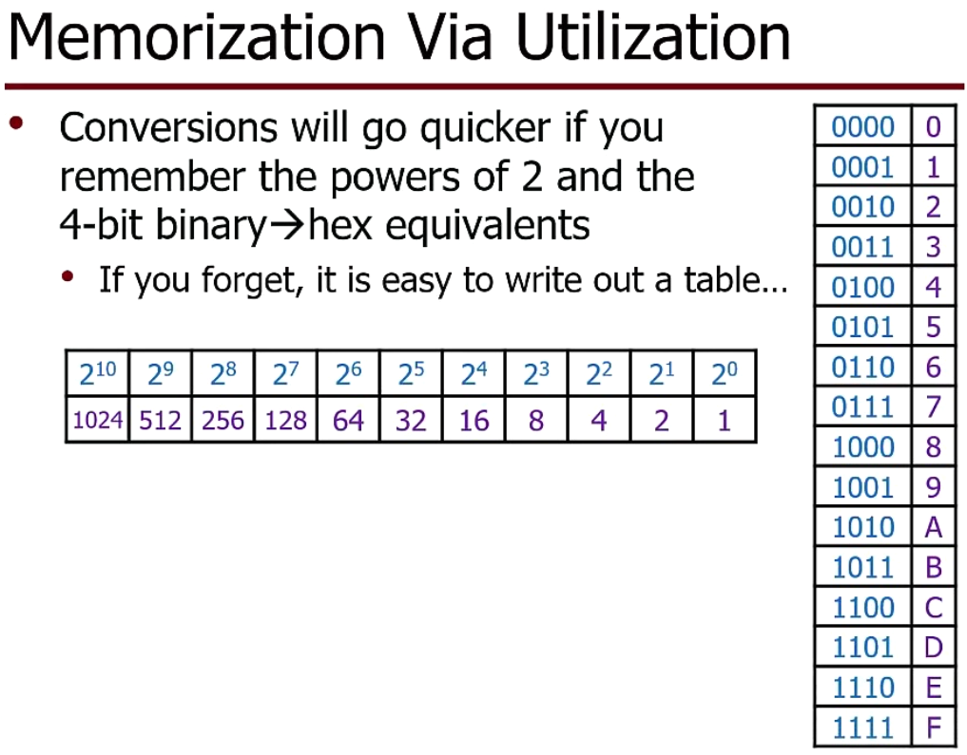
Addition Operation:
(1) know Binary example.
(2) for Octal/Hex, either convert to Binary -> add -> convert back, or use convert to Decimal -> add -> convert back.
(3) Remember: break operation column by column, from right to left
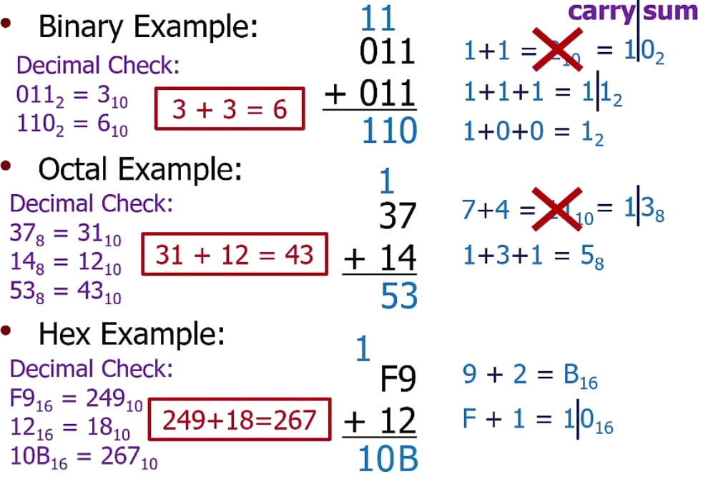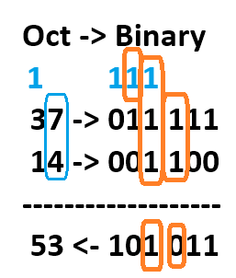
Multiply by Power of Base: add 0s
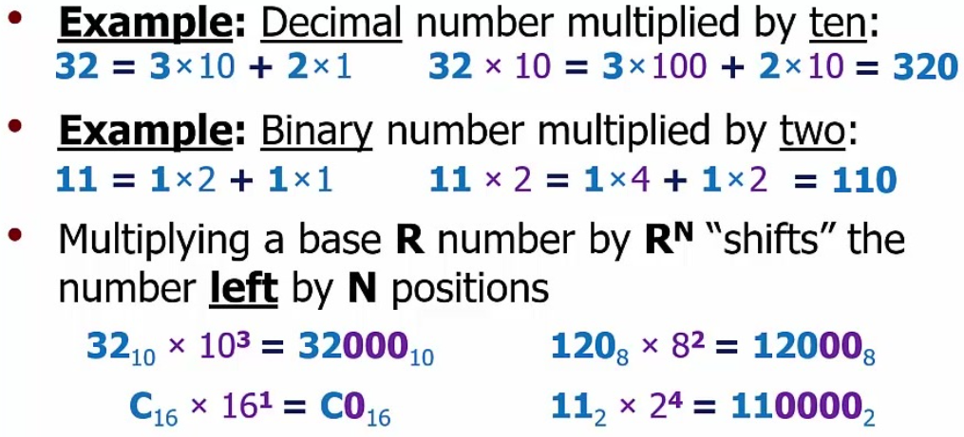
Divide by Power of Base: remove 0s
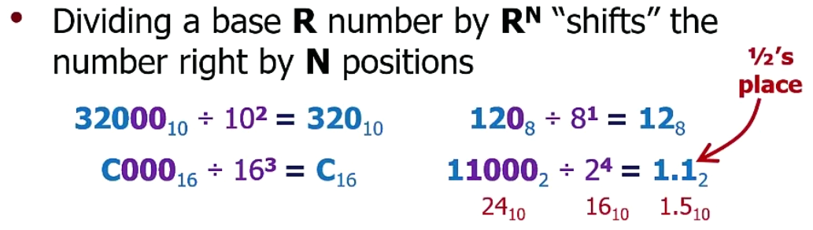
Signed-Magnitude Representation: a side track, NOT used by computer at all!
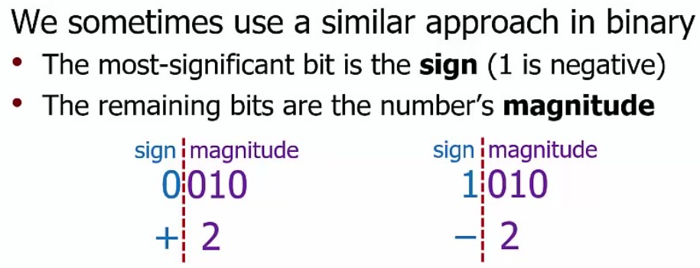
It has two problems: (1) binary addition does NOT work !! (2) two zeros, wasting resource.
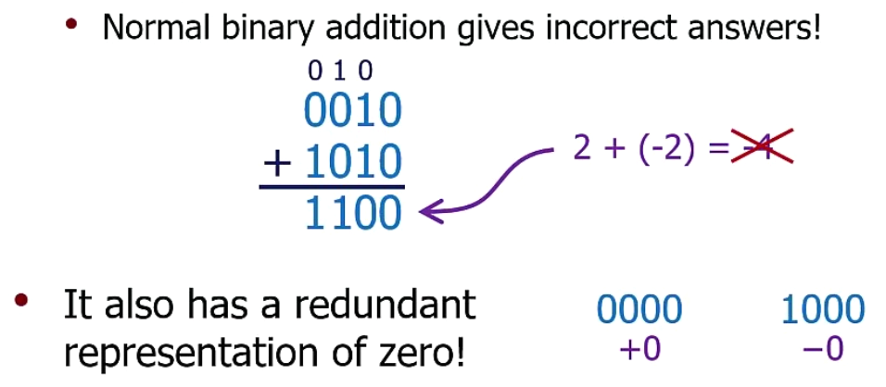

2’s-complement Representation: solved the problem. USED in computer!
In this format, “+5” is “0101”, “-5” is “1011” -> add together (binary arithmetic) -> get “0” as expected!
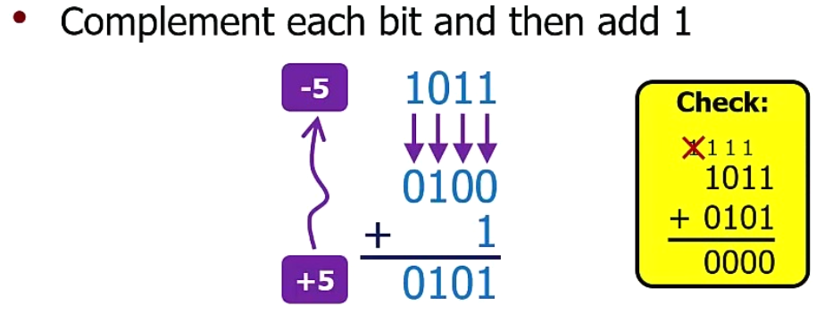
Things to remember:
- First bit “0”, positive number. First bit “1”, negative number.
- “flip and plus 1” -> get negative of a number. “0101” (+5) <--> “1011” (-5)
- find value of binary in 2’s-complement format:
  - “0101”-> positive number -> normal way -> value is +5
  - “1011”-> negative number -> flip “0100” plus 1 “0101” -> it is +5 -> value is “-5”
What is the 2’s-complement format?
remember 3 bit and 4 bit cases, then extend to any number of bits case.
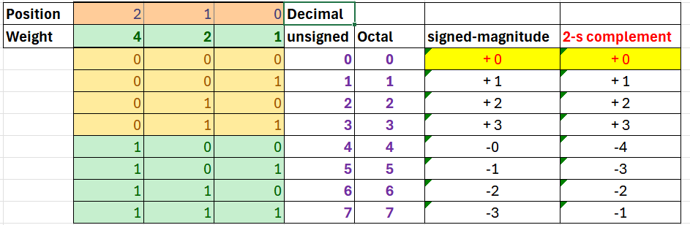
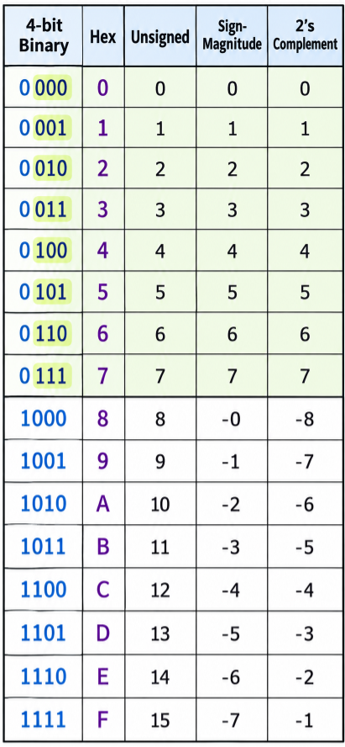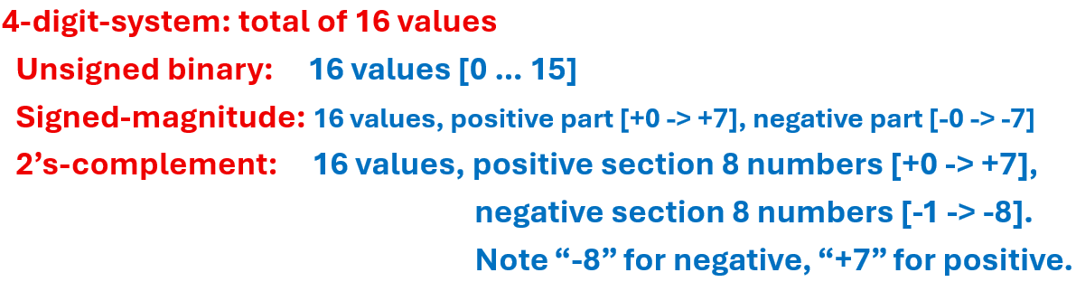

Exercise: on modern 64 bit computer, what are ranges for “unsigned int, signed int” types, min/max values in decimal / binary format ?

- Addition operation:
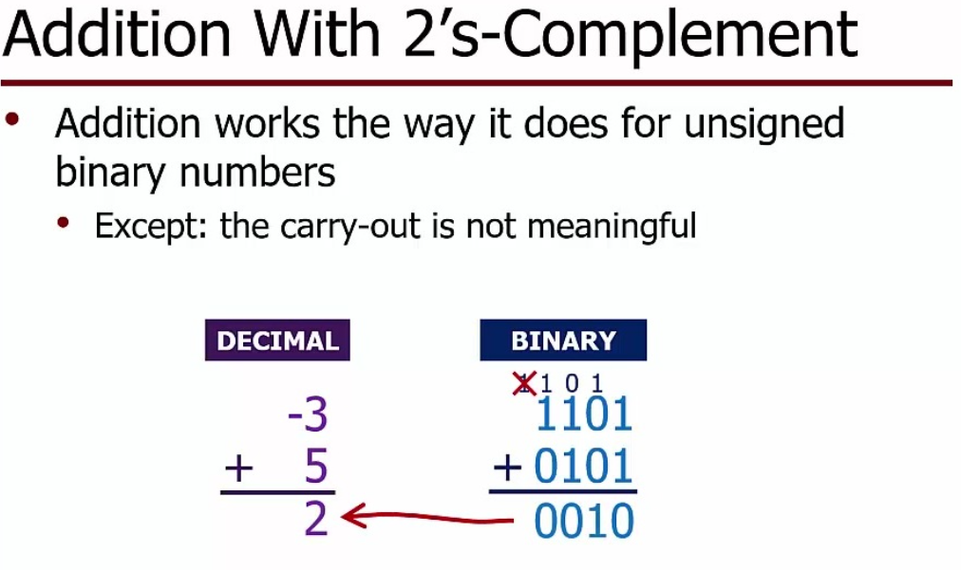
Subtraction -> just add the negation of the value -> “2 – 3” -> “2 + (-3)”
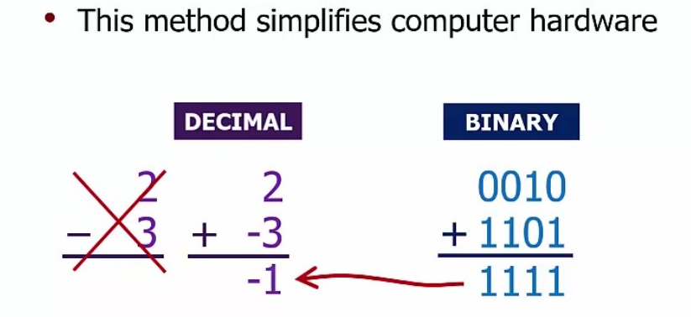
How do we know the results are correct ? Check the signs of (a, b, c)
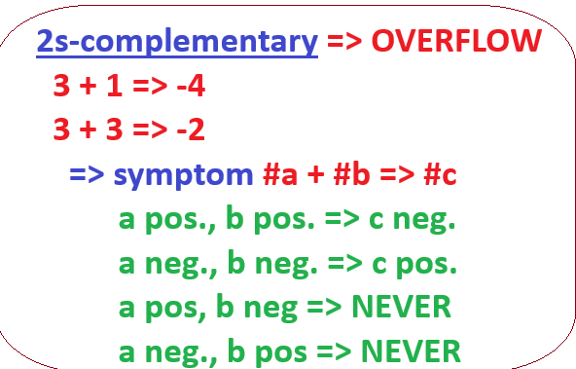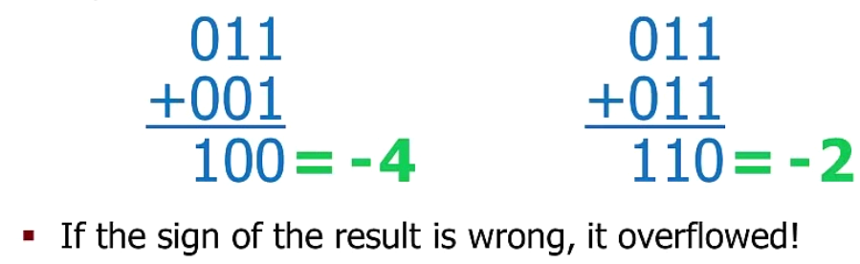
Overflow -> meaning ERROR happened
- Unsigned binary format -> if it creates carry bits, but it will be ignored/skipped -> then overflow
Example: 4 bit digit system, “1111” + “0010” -> will create a carry bit, need 5th bit -> OVERFLOW
- 2’s-complement format -> NOT checking carry bit -> check the signs of “a, b, c”.
Example: “1000 + 1000 => 0000”, a negative, b negative, c is zero, Overflow!

Sign Extension
- Unsigned binary representation -> positive numbers -> ALWAYS add 0s
- 2’s-complementation format
-> positive number -> same as (1), ALWAYS as 0s
-> negative number -> AWLAYS add 1s
